BGA Grading Policy for Virtual Learning
UPDATED- May 18, 2020

Overview
From BPS documents:
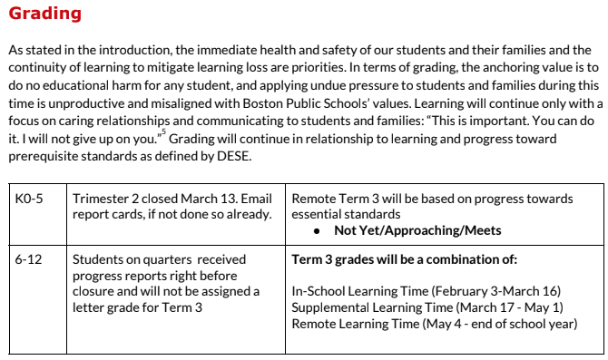
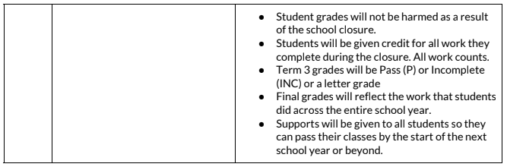

(more→)

Details
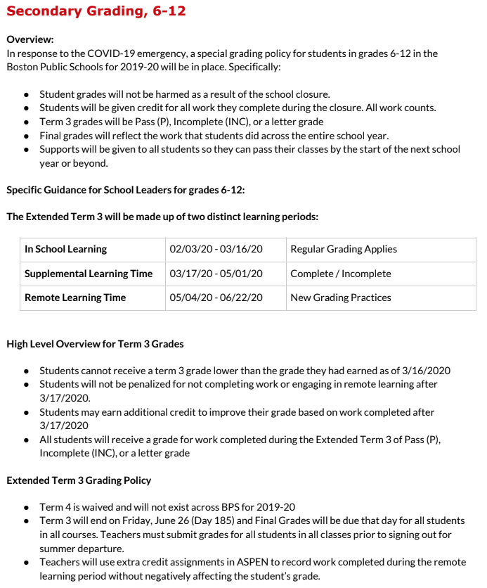
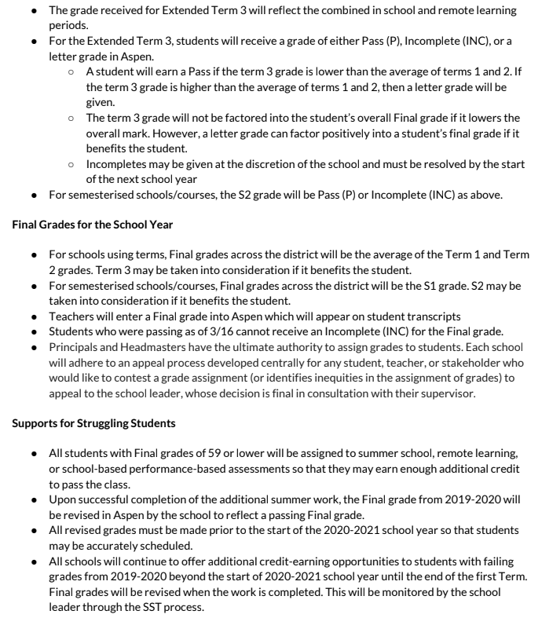
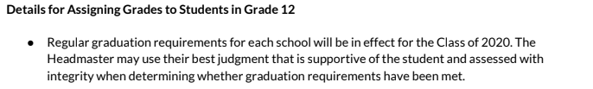
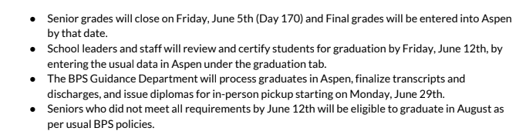

Retention*
(*this will need to be discussed for what it means at BGA)
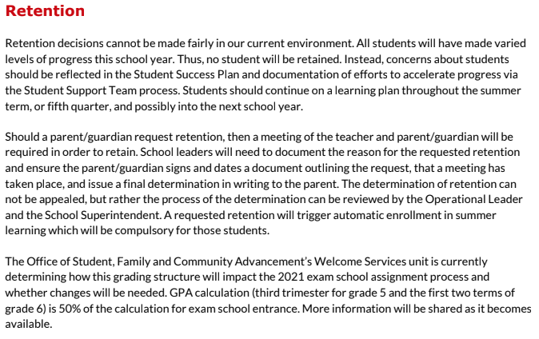

BGA-Specific Clarifications
The ILT/LT have worked hard to clarify what this policy means at BGA. Here are some key things to consider:
- Students in grades 6, 7, and 8 will be promoted to the next grade level. Students may fail any individual class based on their grades. Families may request retention as per BPS policy but the ultimate decision lies with the Headmaster provided the process listed above is followed.
- Students in grades 9, 10, and 11 will be promoted to the next grade level but ultimately must meet all BGA credit and graduation requirements. Students may fail any individual class based on their grades. Families may request retention as per BPS policy but the ultimate decision lies with the Headmaster provided the process listed above is followed.
- Students in any grade 6-11 who fail courses will be automatically given ‘extended work’ as an opportunity to improve the final grade on record. This includes enrollment in summer school and/or will be given performance-based work by BGA teachers to complete over the summer. This work can include Accellus units or full courses, portfolio or performance-based work, and/or the opportunity to make up/improve upon previous assignments.
  - If the extended work is completed satisfactorily or they earn a passing grade in summer school by the start of the 20-21 school year they will earn a passing grade and will be scheduled into the next appropriate level of class.
  - Students who do not satisfactorily complete extended work by the start of the 20-21 school year may be scheduled to repeat a class alongside their schedule at the next grade level.
  - All work that can be considered to modify/improve a grade from 19-20 must be completed by the end of T1 of 20-21
- Many students will be eligible for ‘extended work’ to improve their grade. Examples of extended work include a full or partial Accellus course, a portfolio of key assignments assigned by the teacher, revision of major assignments with teacher approval, successful completion of competency-based online activities (i.e. 15 standards in IXL with a passing score of 80+, completion of 5 Achieve articles and questions for ELA credit, etc.). Teachers are encouraged to give students targeted skills-based work that addresses learning gaps, rather than whole-sale repeats of entire courses whenever possible.
- Term 3 has several components listed above. For the purposes of calculation at BGA, we suggest weighing all three parts equally. However, it is obviously difficult to calculate as the second part (supplemental learning time) is only Complete/Incomplete. We suggest using a range between Complete (80) and Incomplete (40). However, please use your judgment. If your overall T3 calculation appears accurate compared to your assessment of the students work and skills, then use it. If the overall T3 grade does not appear accurate based on your judgment, then adjust it. As long as you grade has integrity, the judgment of the instructor may be used.
- Incompletes for Final Grades may only be issued under two circumstances and only with permission of the Headmaster:
  - Medical reasons (with notes or verification), including COVID-19
  - If other extenuating circumstances interfered with a student’s ability to complete work (documented by a family member or other authority). Examples include being forced to leave the City or country for a period of time, major family disruptions, the need to work to combat economic instability, or other extenuating circumstances.
  - All INC’s must be converted to grades by the start of the 2020-21 school year. Teachers who issue INC’s with approval from the Headmaster are responsible for tracking and supporting the student so they can successfully earn a passing grade.

Scenarios for Grading Students

Scenario | T1 | T2 | T3 | Final Grade | Notes
1 | A  (95) | A (95) | A (95) | A(95) | Students who pass all three terms receive a passing final letter grade
2 | D-  (60) | D-  (60) | F  (40) | D-  (60) | Failing T3 cannot result in a final grade lower than the average of T1 and T2; eligible for extended work to improve grade throughout summer and end of T1 20-21.
3 | F (40) | F (40) | F (40) | F (40) | Student fails for the year; automatically assigned to ‘extended work’ (aka Summer School, portfolio, etc.). Has until end of T1 in 20-21 to complete.
4 | B-  (80) | F  (40) | F  (40) | D- (60) | Failing T3 cannot result in a final grade lower than the average of T1 and T2; eligible for extended work to improve grade through summer and end of T1 20-21.
5 | A (95) | A (95) | F (40) | A (95) | Failing T3 cannot result in a final grade lower than the average of T1 and T2
6 | F (40) | D (65) | B (85) | D- (63) | Completion of T3 work raised grade above failing average of T1 and T2; eligible for extended work to improve grade through summer and end of T1 20-21.
7 | C (75) | D (65) | F (59) | D (66) | Failing T3 cannot result in a final grade lower than the average of T1 and T2; eligible for extended work to improve grade through summer and end of T1 20-21.
8 | C (75) | F (40) | INC | INC | INCs may only be granted for medical reasons with permission of the Headmaster. Student will be assigned extended work in summer 2020. Final grade issued before start of 20-21 school year. Student has until end of T1 in 20-21 to improve grade based on additional work.

